1. Add Custom Network

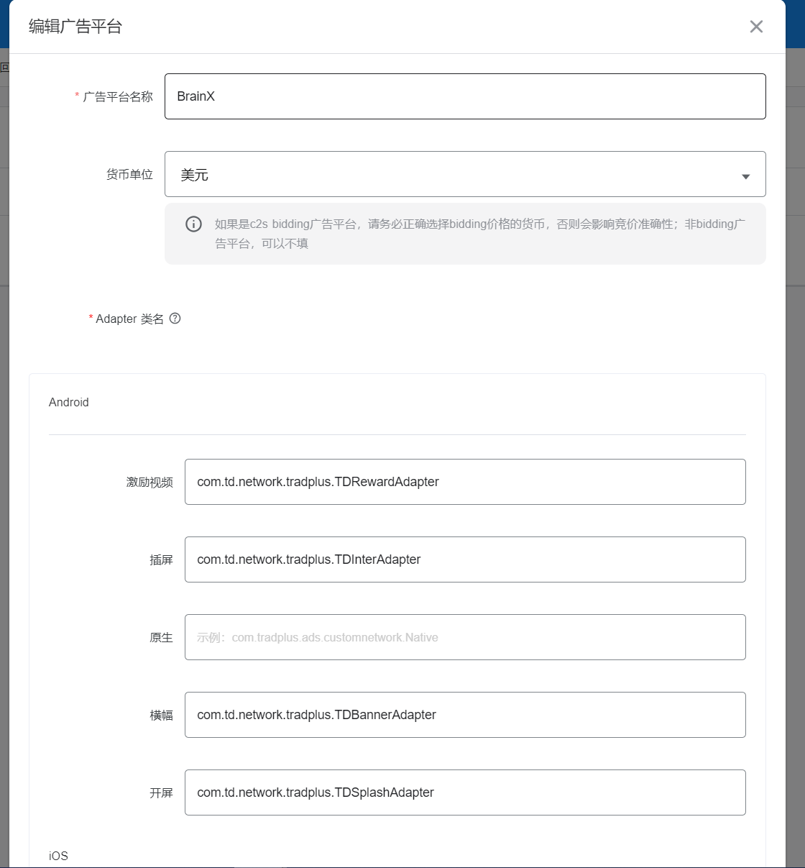

RewardVideo: com.td.network.tradplus.TDRewardAdapter

Interstitial: com.td.network.tradplus.TDInterAdapter

Banner: com.td.network.tradplus.TDBannerAdapter

Splash: com.td.network.tradplus.TDSplashAdapter

1. Add ad source

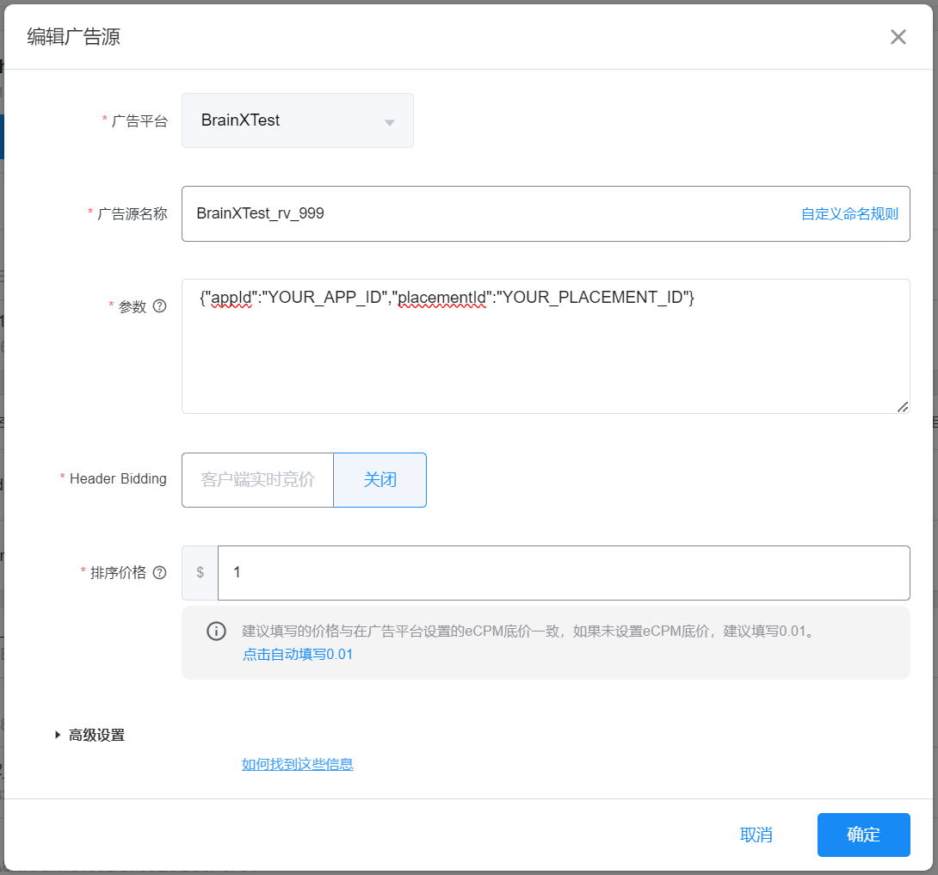

Parameter: {"appId":"YOUR_APP_ID","placementId":"YOUR_PLACEMENT_ID"}

Notice：SDK Proguard rules：  
     -keep class com.td.** { *; }  
    -keepclassmembers class com.td.** {  
        @com.td.* public *;  
    }